Serverless computing
1. S3 bucket
Create a source bucket – msissourcebucket
Upload images.jpg

Create a destination bucket – msissourcebucket-resized
This is where the resized files will be reflected

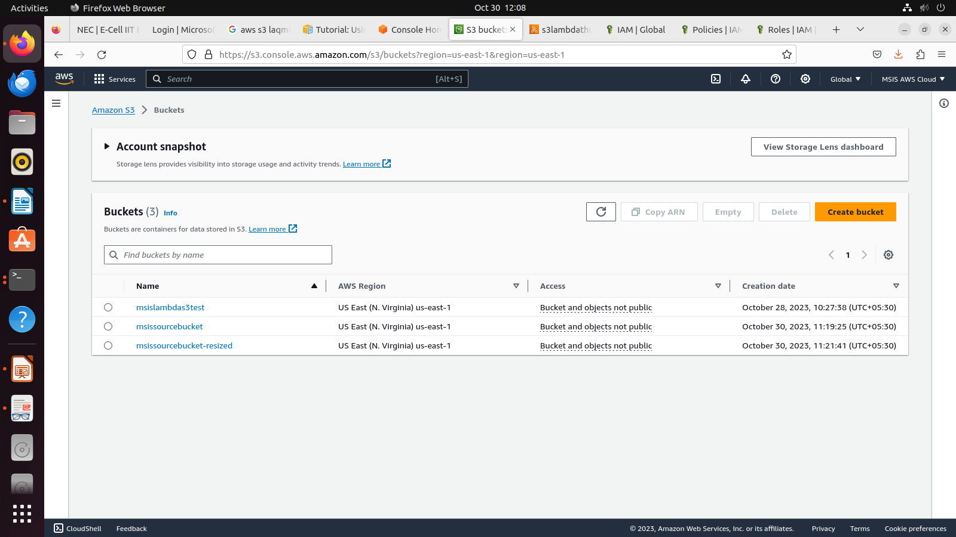
2. Policy
Create a policy in json format (s3lambdathumbnailpolicy)
{
"Version": "2012-10-17",
"Statement": [
{
"Effect": "Allow",
"Action": [
"logs:PutLogEvents",
"logs:CreateLogGroup",
"logs:CreateLogStream"
],
"Resource": "arn:aws:logs:*:*:*"
},
{
"Effect": "Allow",
"Action": [
"s3:GetObject"
],
"Resource": "arn:aws:s3:::*/*"
},
{
"Effect": "Allow",
"Action": [
"s3:PutObject"
],
"Resource": "arn:aws:s3:::*/*"
}
]
}

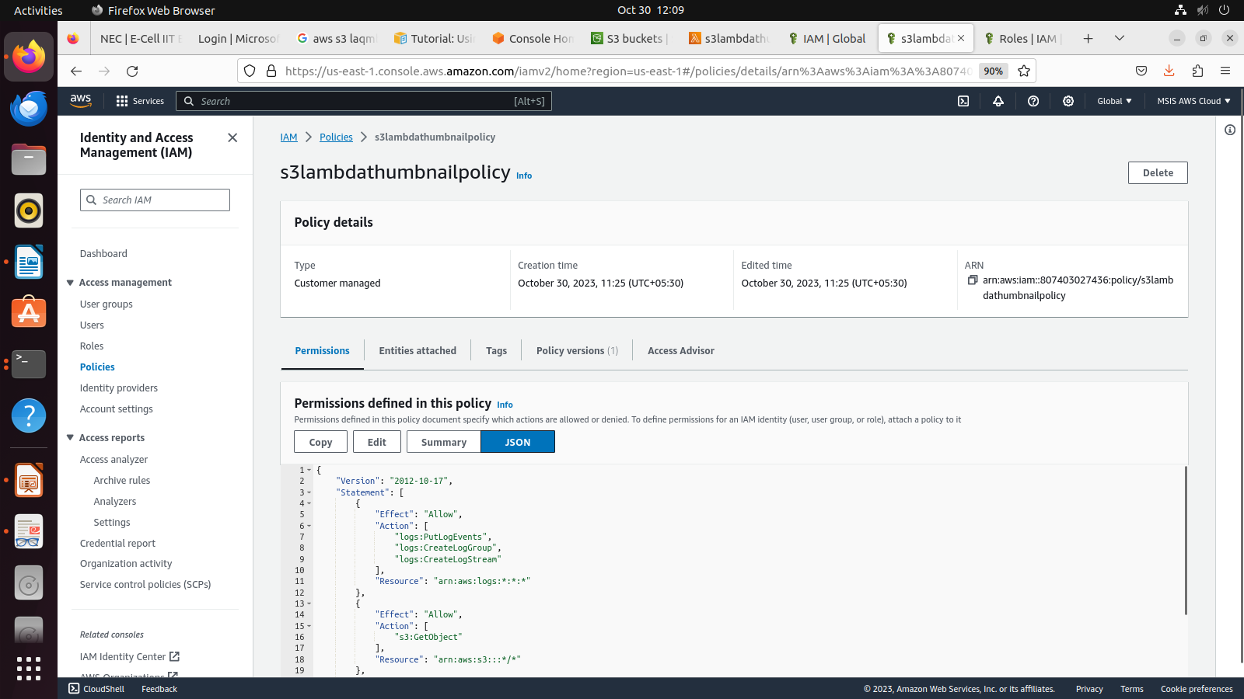
3. Create role
Create an IAM role (s3lambdathumbnailrole)
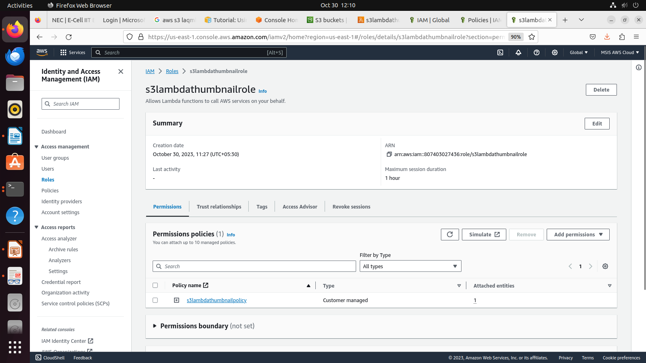

4. Create lambda function
s3lambdathumbnail – name
Choose python 3.9
x86_64
Attach an existing role
Create function

Add a trigger
s3 bucker
Go to code and add zip code (tutorial)
https://docs.aws.amazon.com/lambda/latest/dg/with-s3-tutorial.html

import boto3
import os
import sys
import uuid
from urllib.parse import unquote_plus
from PIL import Image
import PIL.Image

s3_client = boto3.client('s3')

def resize_image(image_path, resized_path):
with Image.open(image_path) as image:
image.thumbnail(tuple(x / 2 for x in image.size))
image.save(resized_path)

def lambda_handler(event, context):
for record in event['Records']:
bucket = record['s3']['bucket']['name']
key = unquote_plus(record['s3']['object']['key'])
tmpkey = key.replace('/', '')
download_path = '/tmp/{}{}'.format(uuid.uuid4(), tmpkey)
upload_path = '/tmp/resized-{}'.format(tmpkey)
s3_client.download_file(bucket, key, download_path)
resize_image(download_path, upload_path)
s3_client.upload_file(upload_path, '{}-resized'.format(bucket), 'resized-{}'.format(key))

lambda_function.py
mkdir package
pip install \
--platform manylinux2014_x86_64 \
--target=package \
--implementation cp \
--python-version 3.9 \
--only-binary=:all: --upgrade \
pillow boto3

zip file
cd package
zip -r ../lambda_function.zip .
cd ..
zip lambda_function.zip lambda_function.py

lambda package consists of code and dependency

import os, sys – has all the commands(service, ls, mkdir)
PIL- pillow library for resizing

* pip & conda -> python package manager

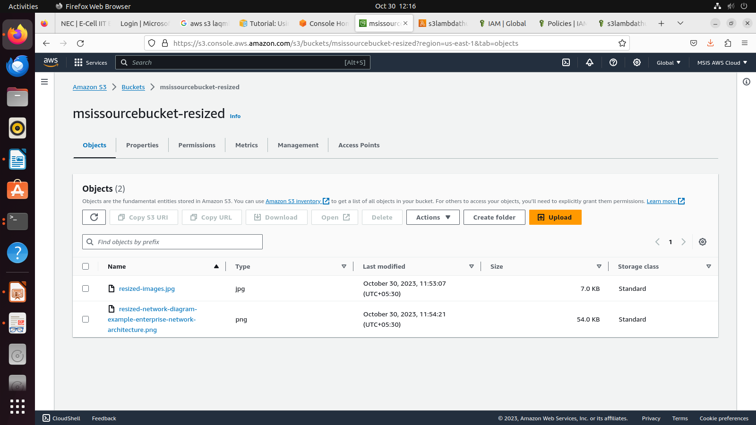

Test
{
"Records": [
{
"eventVersion": "2.0",
"eventSource": "aws:s3",
"awsRegion": "us-east-1",
"eventTime": "1970-01-01T00:00:00.000Z",
"eventName": "ObjectCreated:Put",
"userIdentity": {
"principalId": "EXAMPLE"
},
"requestParameters": {
"sourceIPAddress": "127.0.0.1"
},
"responseElements": {
"x-amz-request-id": "EXAMPLE123456789",
"x-amz-id-2": "EXAMPLE123/5678abcdefghijklambdaisawesome/mnopqrstuvwxyzABCDEFGH"
},
"s3": {
"s3SchemaVersion": "1.0",
"configurationId": "testConfigRule",
"bucket": {
"name": "msissourcebucket",
"ownerIdentity": {
"principalId": "EXAMPLE"
},
"arn": "arn:aws:s3:::msissourcebucket"
},
"object": {
"key": "images.jpg",
"size": 1024,
"eTag": "0123456789abcdef0123456789abcdef",
"sequencer": "0A1B2C3D4E5F678901"
}
}
}
]
}

